**Group Report**

COMP1640 - Enterprise Web Software Development

**Subject Code:** COMP1640

**Subject Title:** Enterprise Web Software Development

**Team Name:** *Manucian*

**Submission Date:** *19/04/2023*

**Team Information**

|  |  |
| --- | --- |
| Full Name | UoG Id |
| Nguyen Le Anh Tai | 001325719 |
| Tran Huu Viet Duc | 001324404 |
| Hoang Hai Long | 001324891 |
| Ngo Hoang Anh | 001324423 |

Contents

1. Introduction about the project 4

2. Group Information summary 4

3. Team Members information 4

4. Agile Documentation and Artifacts 4

4.1 Product Backlog 4

4.2 Daily Meetings 4

4.3 Sprint 1 4

4.3.1 Sprint Backlog 4

4.3.2 Burndown Chart 5

4.3.3 Sprint Review 5

4.3.4 Sprint Retrospective 5

4.4 Sprint 2 5

4.4.1 Sprint Backlog 5

4.4.2 Burndown Chart 5

4.4.3 Sprint Review 5

4.4.4 Sprint Retrospective 5

4.5 Sprint 3 5

4.5.1 Sprint Backlog 5

4.5.2 Burndown Chart 5

4.5.3 Sprint Review 5

4.5.4 Sprint Retrospective 5

4.6 Sprint 4 5

4.6.1 Sprint Backlog 5

4.6.2 Burndown Chart 5

4.6.3 Sprint Review 5

4.6.4 Sprint Retrospective 5

5. Design Document 5

5.1 ERD 5

5.2 Sitemap 5

5.3 Wireframes / UI Design 5

6. Implementation 5

6.1 Screenshot of the Project Folder Structure 5

6.2 Screenshot of the final Product 5

6.3 Testing 5

# Introduction about the project

This is a project to create a secure web-enabled role-based system for collecting feedback from personnel. Our system has three key roles: staff, administration, and quality assurance.(QA). The following criteria will be included in the system: Every department has a QA coordinator in charge of overseeing the process and encouraging employees to participate. All staff (academic and support) can submit one or more ideas, and they must agree to the Terms and Conditions before submitting, with the option of including supporting documents. All employees have access to all submitted ideas and can provide comments on any of them. The QA manager has the ability to add new categories at any time and remove current ones if they are no longer required. Ideas and comments can be submitted anonymously; once published, the system will send an email to the Department QA Coordinator, as well as the originator of the idea. An administrator will be in charge of keeping all system data up to date, and the interface should be interoperable with all devices.

# Group Information summary

|  |  |
| --- | --- |
| Team Name | *TeamName* |
| Group Repository | [*Github - Manucian Team*](https://github.com/tainlagcd191069/-Enterprise-Web-Software-Development) |
| Group Board URL | [*Manucian Team - Jira*](https://manucian.atlassian.net/jira/software/projects/IC/boards/1/backlog) |
| Deployment URL |  |
| Front End Tech | *React, JS* |
| Back End Tech | *.NET/.NET Core* |
| Database Tech | *MongoDB* |
| Screen Cast URL | [*YouTube*](https://www.youtube.com/watch?v=yKcirFMDb5I) |
| 3rd party services | *Cloudinary / Google Login / etc.* |
| IDE | *Visual Studio Code* |

# Team Members information

|  |  |
| --- | --- |
| Full Name | Role |
| Ngô Hoàng Anh | Developer |
| Trần Hữu Viết Đức | Scrum Master |
| Hoàng Hải Long | Developer |
| Nguyễn Lê Anh Tài | Product Owner |

# Agile Documentation and Artifacts

## Product Backlog

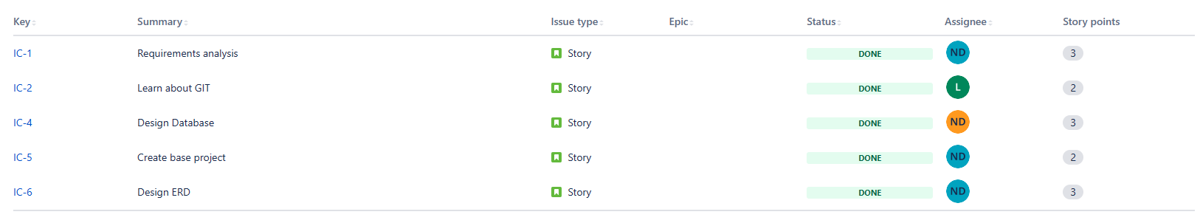

Figure 1: Product Backlog 1

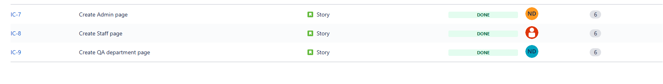

Figure 2: Product Backlog 2

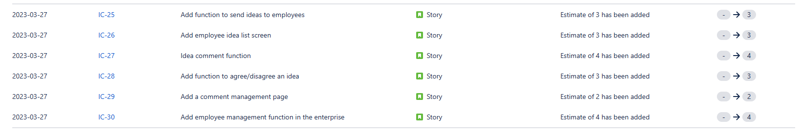

Figure 3: Product Backlog 3

## Daily Meetings

* Our group meets and exchanges information on Google Meeting. We meet together to analyze the requirement and divide the work for each member

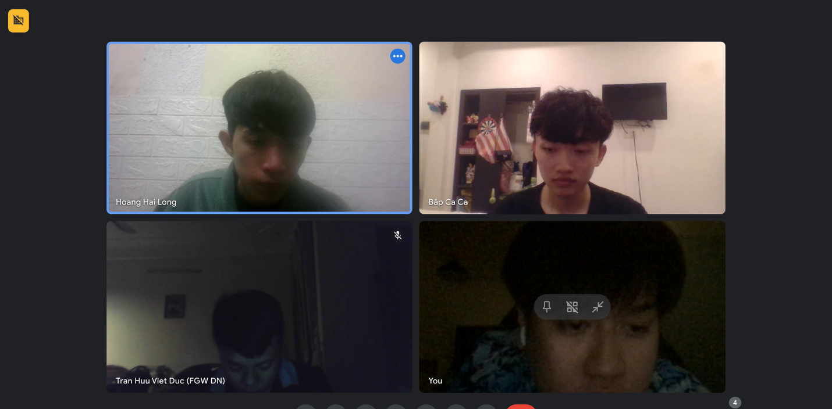

Figure 4: Group Meeting

* The next times we meet to do jira and code, git code on github.

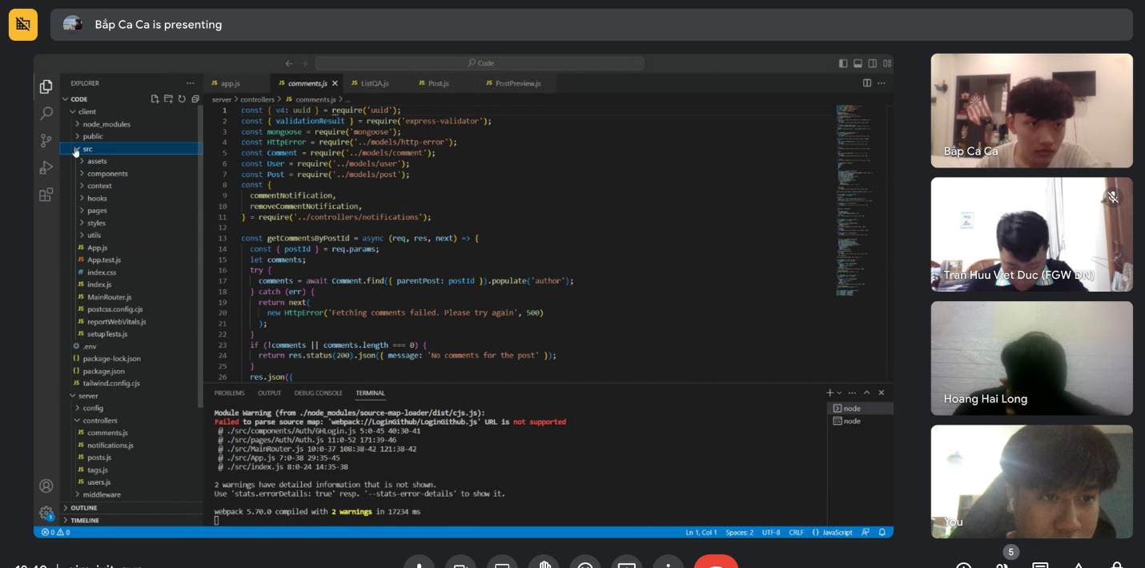

Figure 5: Team Meeting to discuss about code

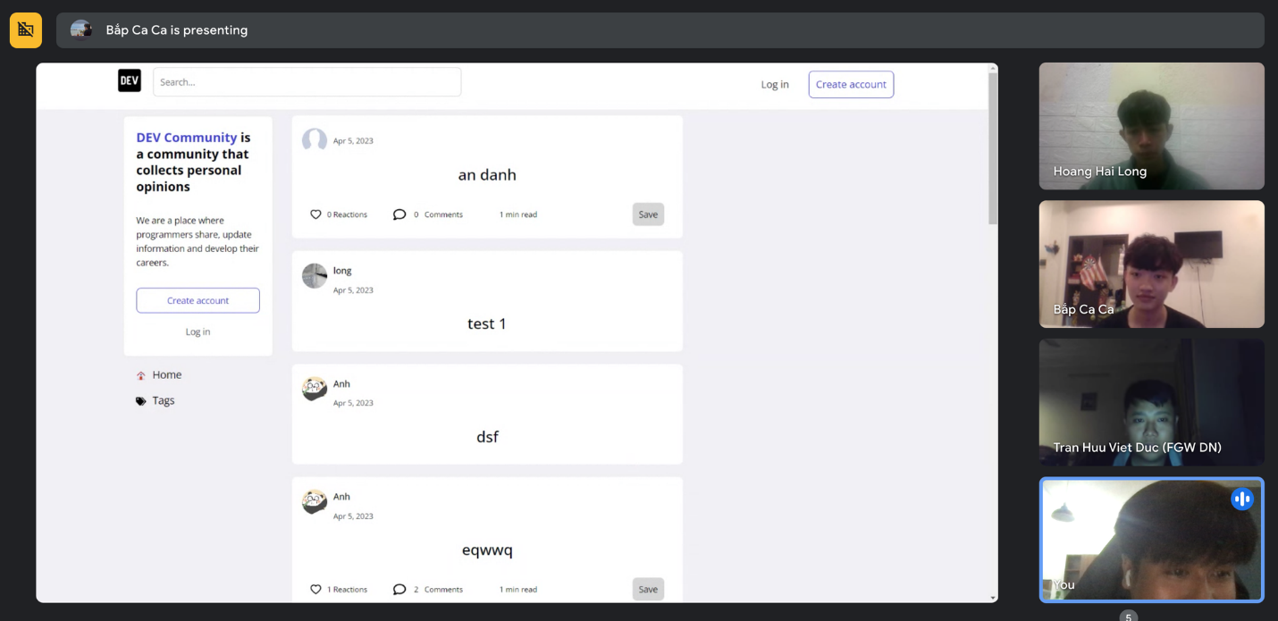

Figure 6: Team Meeting to test application

* We meet to make reports and test the project's functions

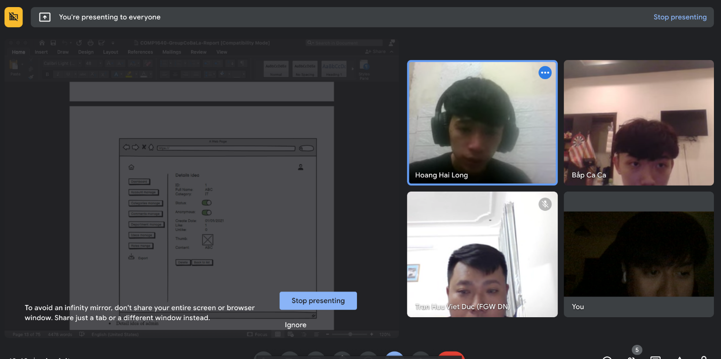

Figure 7: Team meeting to design Mockup

## Sprint 1

### Sprint Backlog

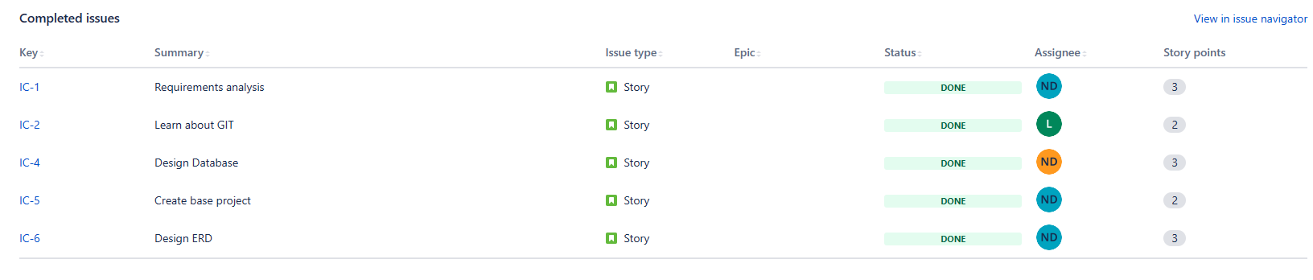

Figure 8: Sprint Backlog 1

These are my team's tasks for sprint 1.

### Burndown Chart

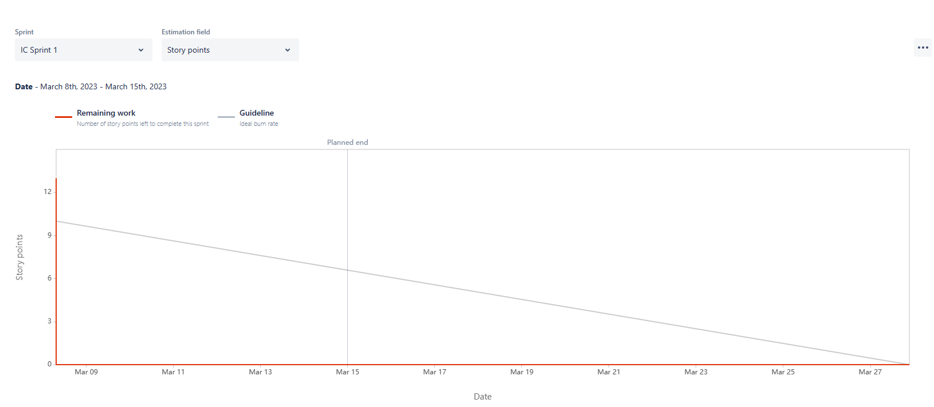

Figure 9: Burndown Chart of Sprint 1

* Sprint 1 was started by us on March 8 and it ran for a week to March 15. In this sprint, we spend a lot of time discussing and raising issues, so there is still a lot of work in the first days of the sprint. In the last phase of the sprint, we had a pretty clear understanding of what needed to be done and accelerated the work to complete the sprint.

## Sprint 2

### Sprint Backlog

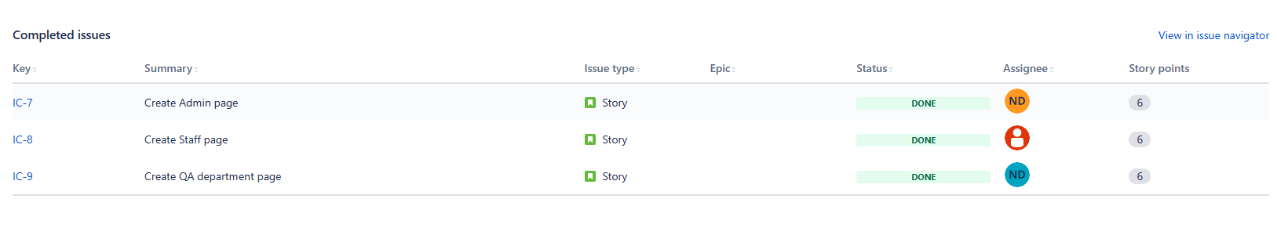

Figure 10: Sprint Backlog 2

### Burndown Chart

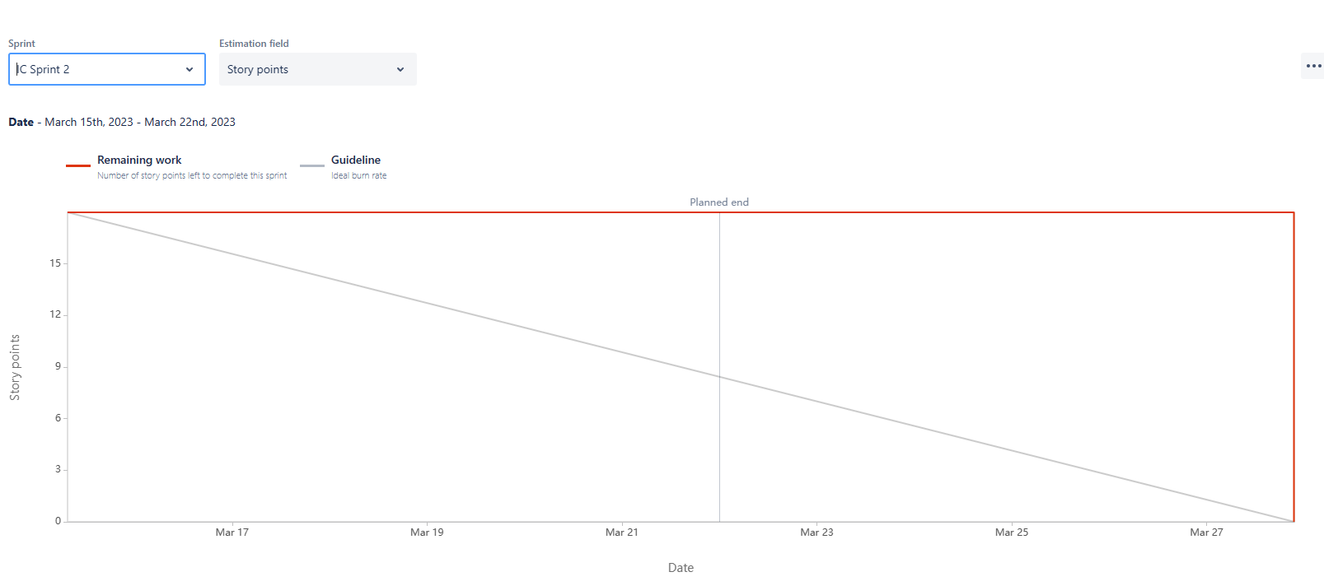

Figure 11: Burndown Chart of Sprint 2

* Our Sprint 2 starts right after we finish the work of sprint 1. In this sprint, we focus on building the UI and the basic functionality included in the 3 main roles.

## Sprint 3

### Sprint Backlog

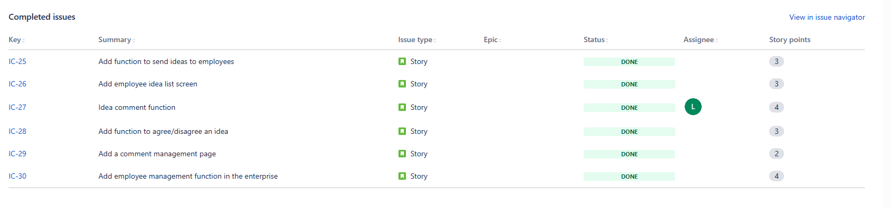

Figure 12: Sprint Backlog 3

### Burndown Chart

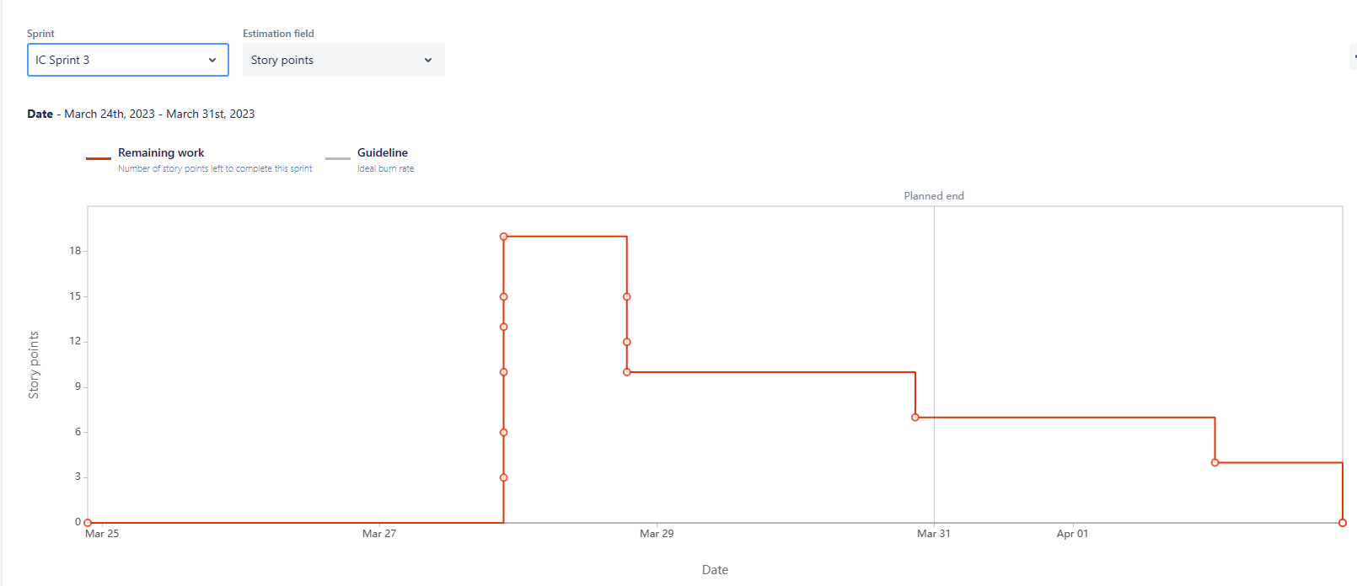

Figure 13: Burndown Chart of Sprint 3

* Our last Sprint ran from March 24 to March 31. In this sprint, we focused on building on the important functionality of each of the different roles. We have divided the appropriate amount of work for each person to be able to finish the sprint on time and in the best way.

# Design Document

## ERD

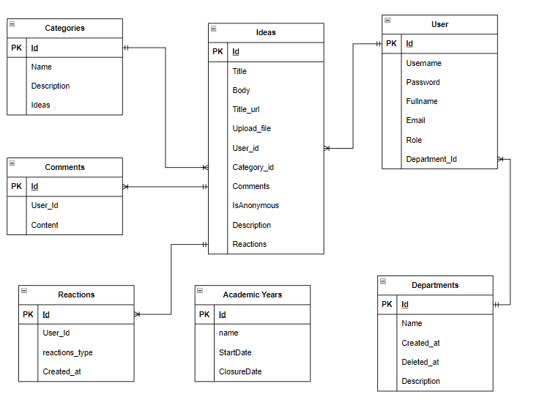

Figure 14: ERD

* Here is the diagram of the application we developed.

## Wireframes / UI Design

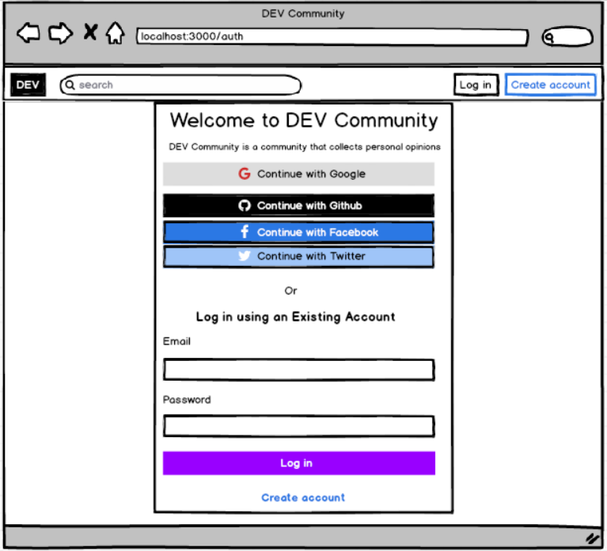

Figure 15: Mockup Login

* This is the login page when you click the login button in the website

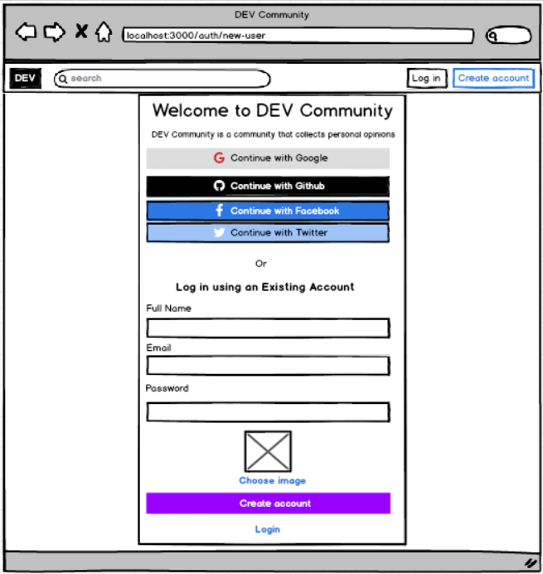

Figure 16: Mockup Create account

* This is the new account creation page. If you do not have an account to log in to the site, click the Create account button on the home page when you visit.

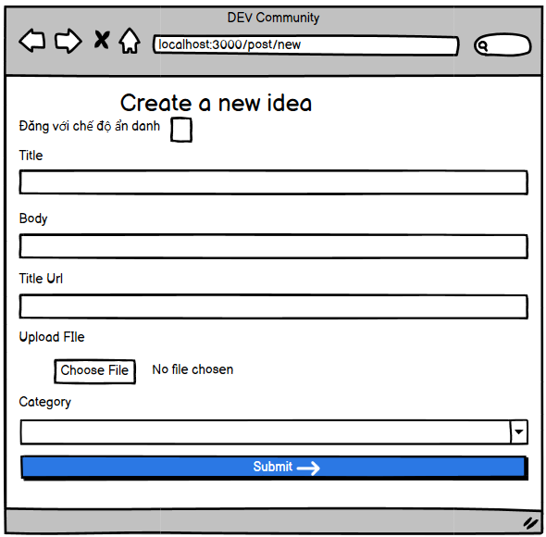

Figure 17: Mockup create Idea

* After logging in, you want to post your idea on the website, click on the Create Post button. This is you create idea page.

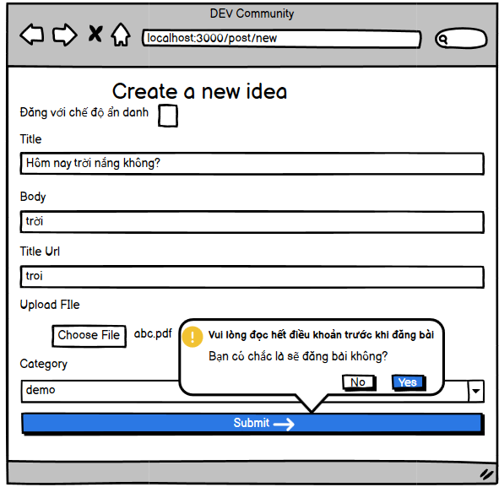

Figure 18: Mockup agree to the terms

* When you click the "Submit" button. The website will appear to agree to the terms before creating an idea

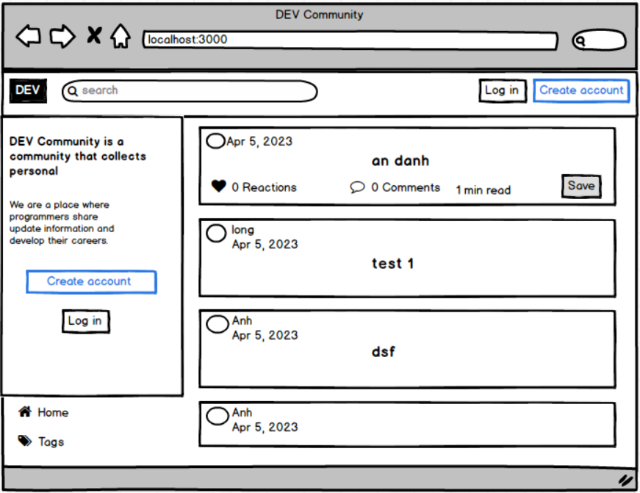

Figure 19: Mockup homepage when not logged in

* This is the home page when you are not logged in. You will see the posted ideas in the website but there is nothing you can do but that

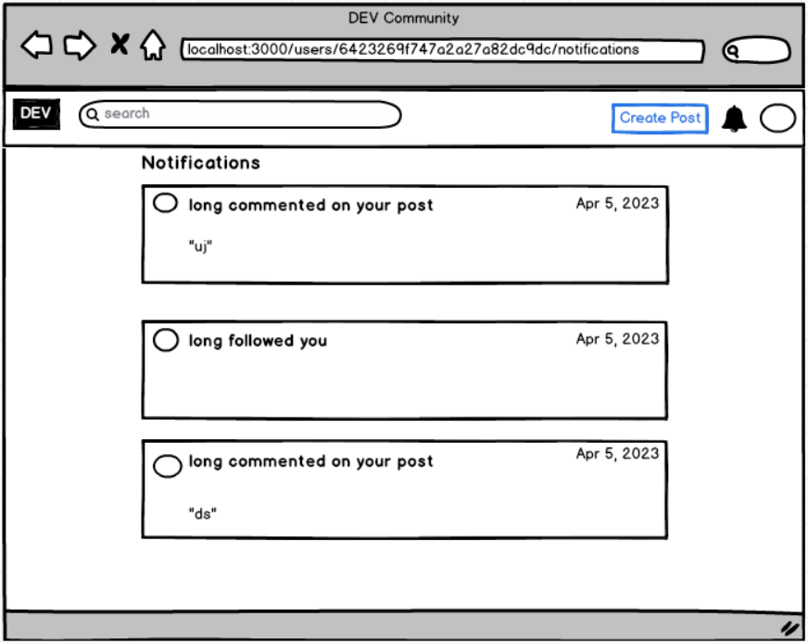

Figure 20: Mockup Notification

* This is the comment and follow page of the Staff when you click on the icon on the page.

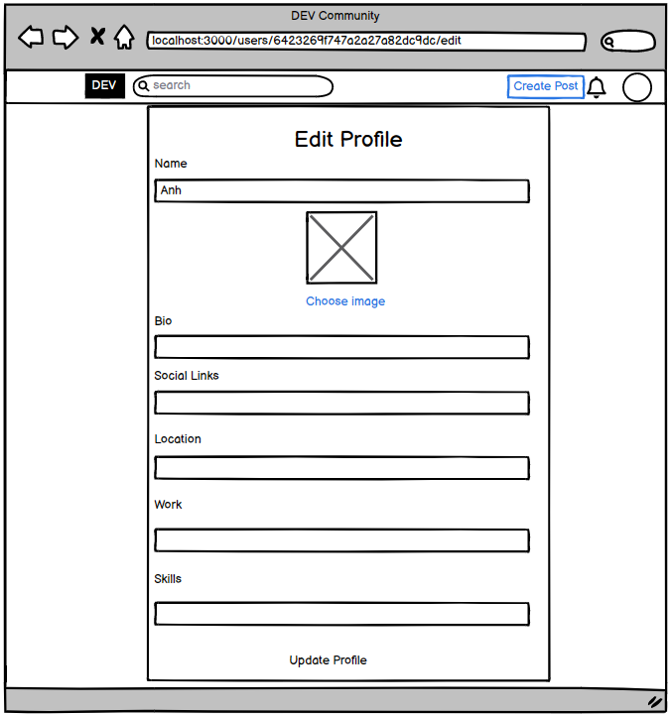

Figure 21: Mockup Edit Profile

* This is the edit profile page. Here you can change your information.

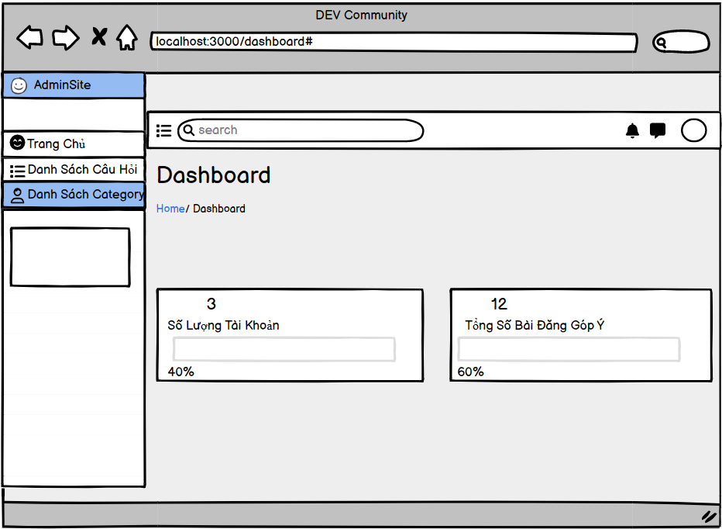

Figure 22: Mockup Dashboard manage by QA

* This is a QA-managed dashboard. QA can see the number of accounts and the number of ideas posted on the site

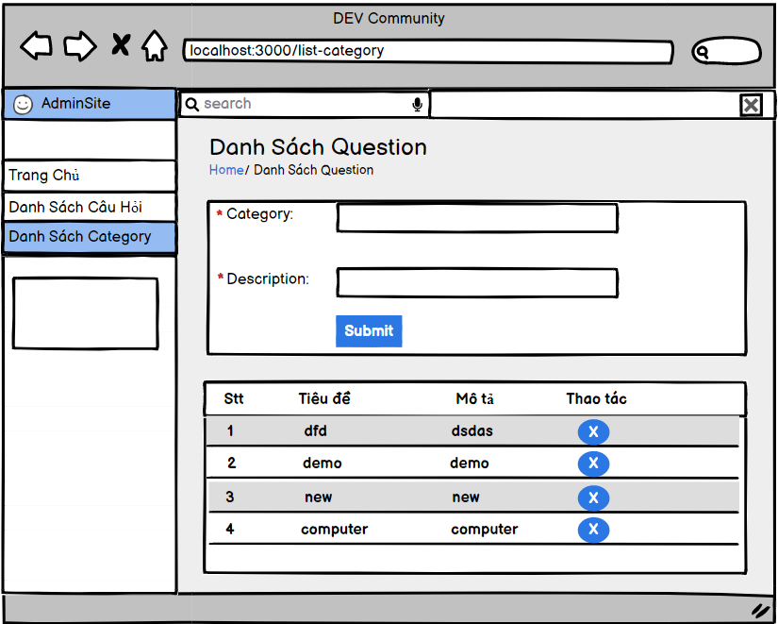

Figure 23: Mockup List of category

* This is the category listing page. You can see previously submitted categories. In addition, you can add or remove categories.

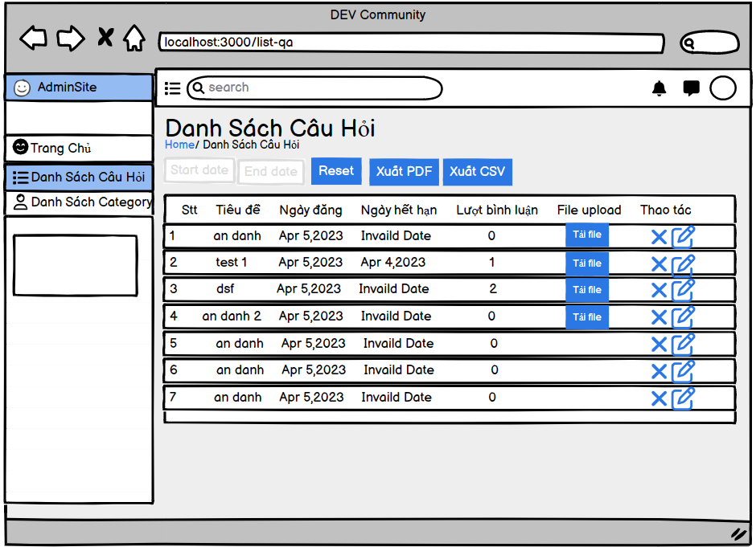

Figure 24: Mockup List of Idea

* This is the "Staff" ideas list page posted. You can "Export PDF" and "Export CSV". Alternatively, you can download the file that "staff" posted in that idea.

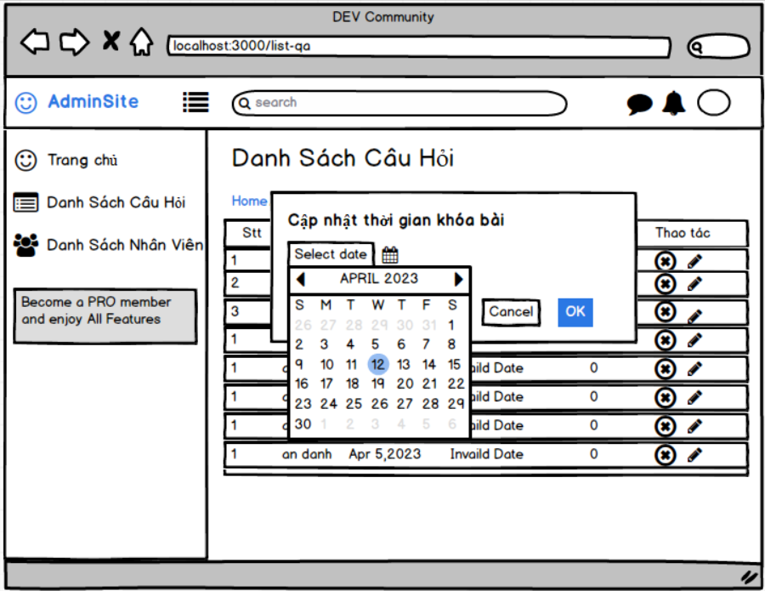

Figure 25: Mockup Update Closure Date Idea

* This is the interface of the idea's expiration date editing page.

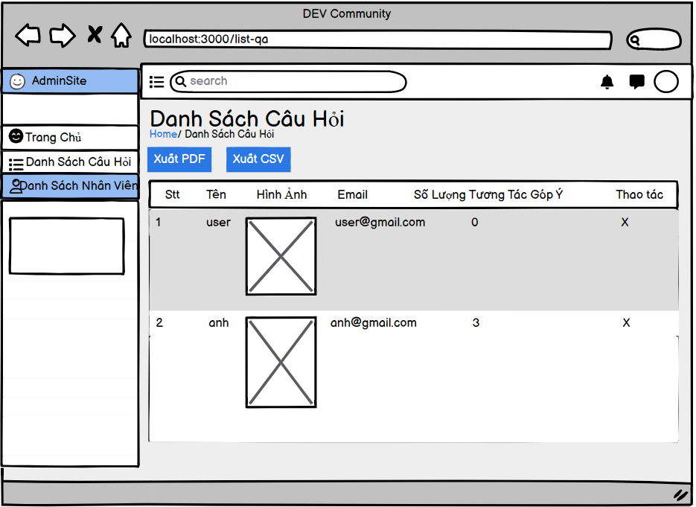

Figure 26: Mockup List of Staff

* This is the employee list mockup page. You can see your name, avatar, email, as well as the number of comments on the site.

# Implementation

## Screenshot of the Project Folder Structure

* Pictures in the product

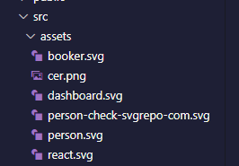

Figure 27: Pictures in the product

* Components used to design HomePage

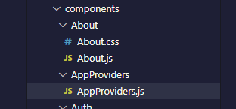

Figure 28: Design HomePage 1

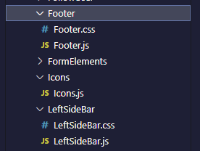

Figure 29: Design HomePage 2

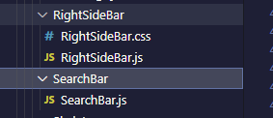

Figure 30: Design HomePage 3

* Component used to design Login

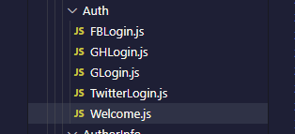

Figure 31: Design Login

* Component used to design Profile

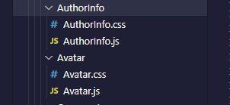

Figure 32: Design Profile

* Component used to design Comment Post

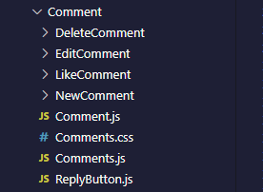

Figure 33: Design Comment Post

* Component used to design Post Idea and some function such as List Idea, CRUD Idea

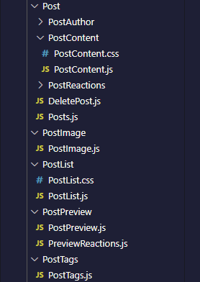

Figure 34: Design Post Idea and some function such as List Idea, CRUD Idea

* Code of project

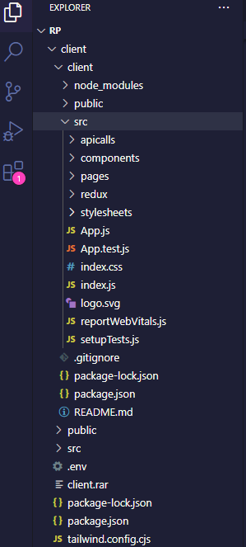

Figure 35: Code of Project 1

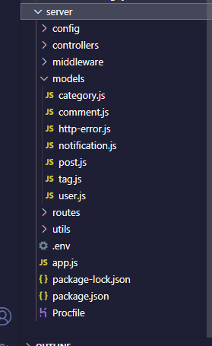

Figure 36: Code of Project 2

## Screenshot of the final Product

Home page

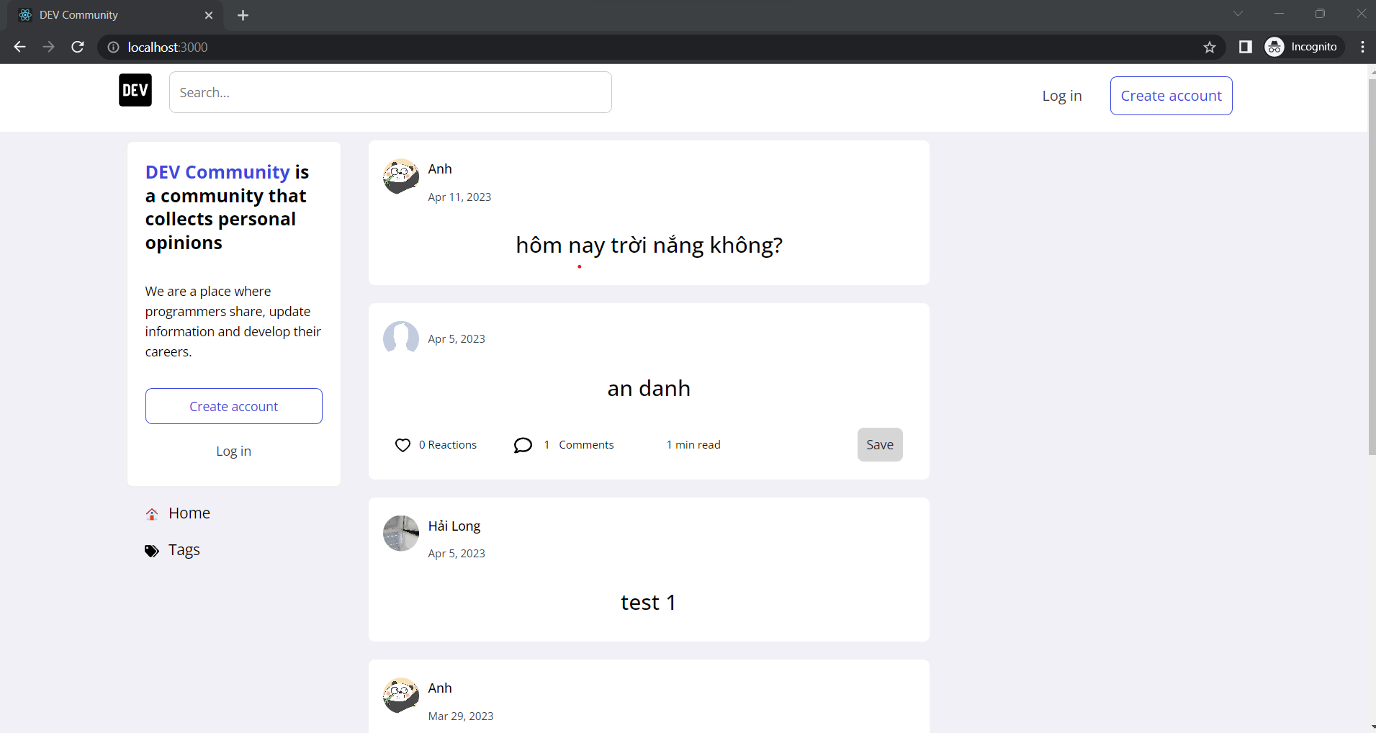

Figure 37: Home Page

Login Page

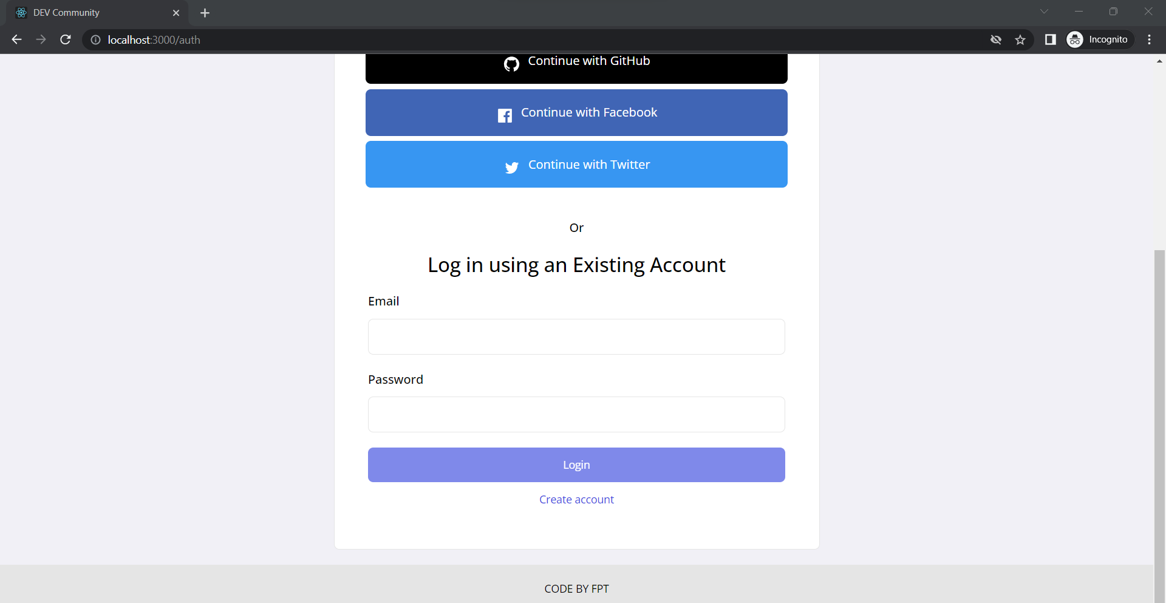

Figure 38: Login Page

Create account Page

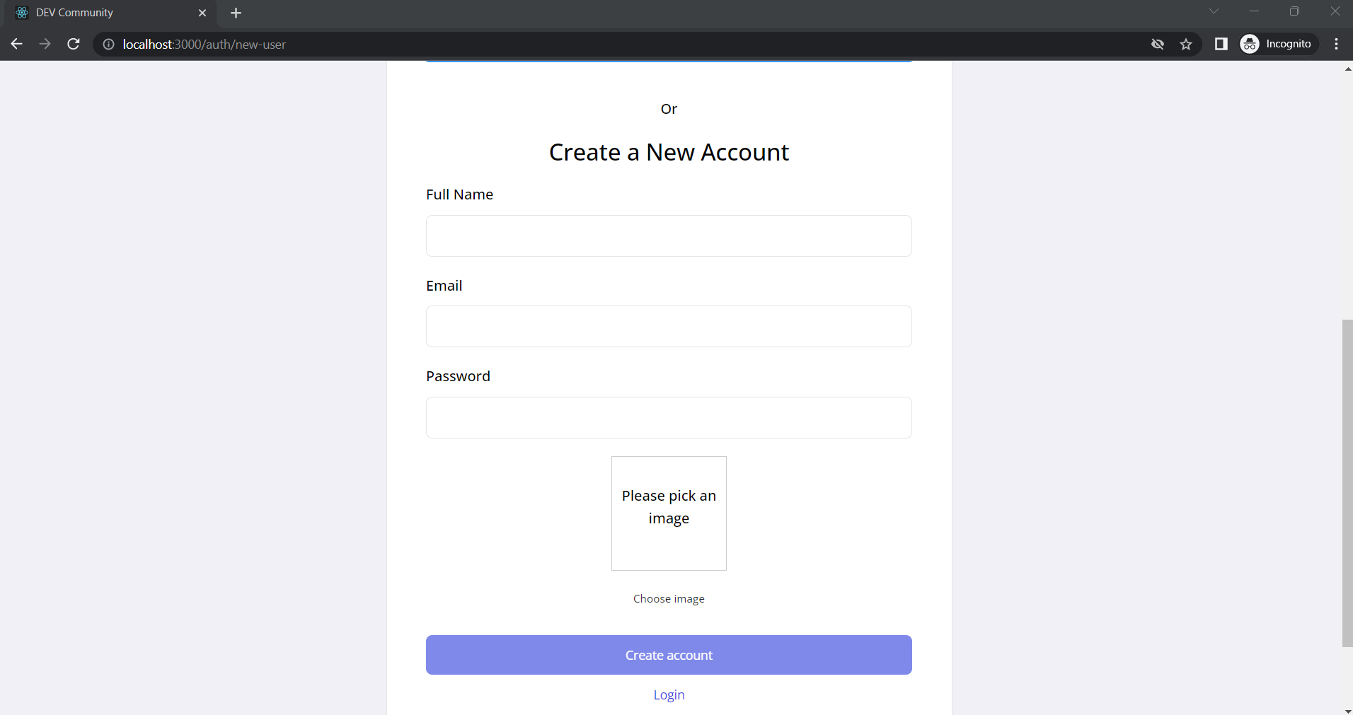

Figure 39: Create account Page

Home page staff

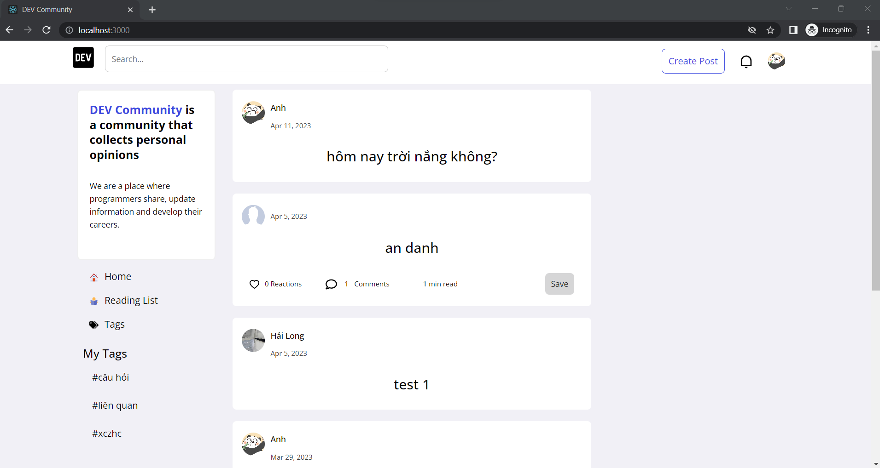

Figure 40: Home page staff

Create idea Page

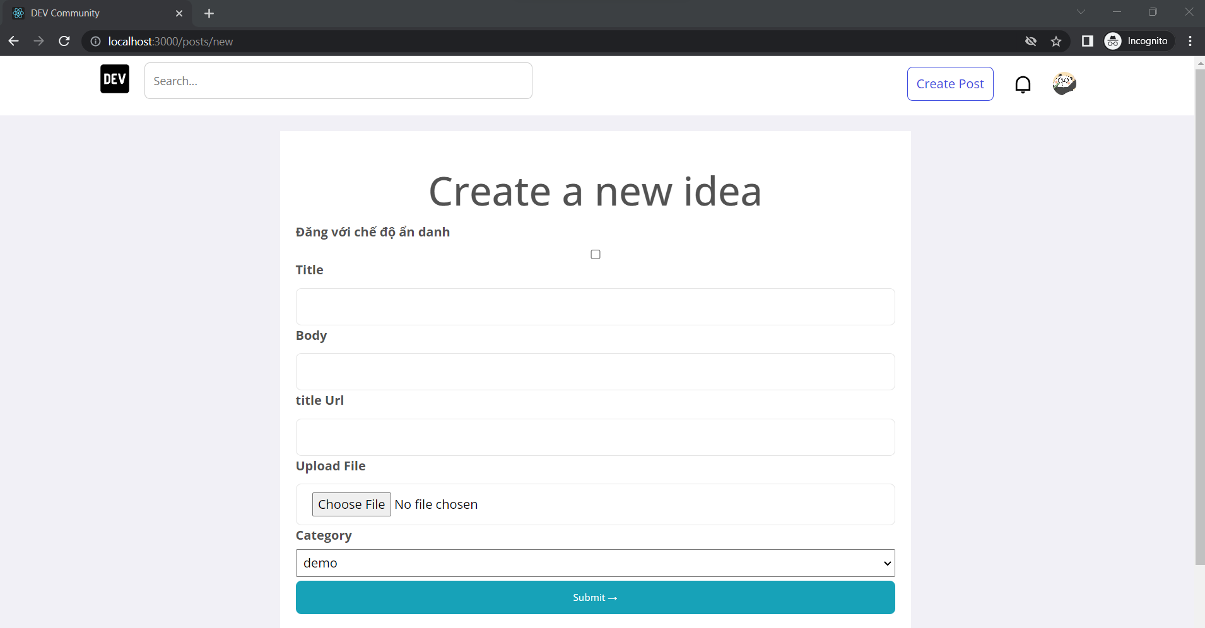

Figure 41: Create idea Page

Agree to terms before posting ideas Page

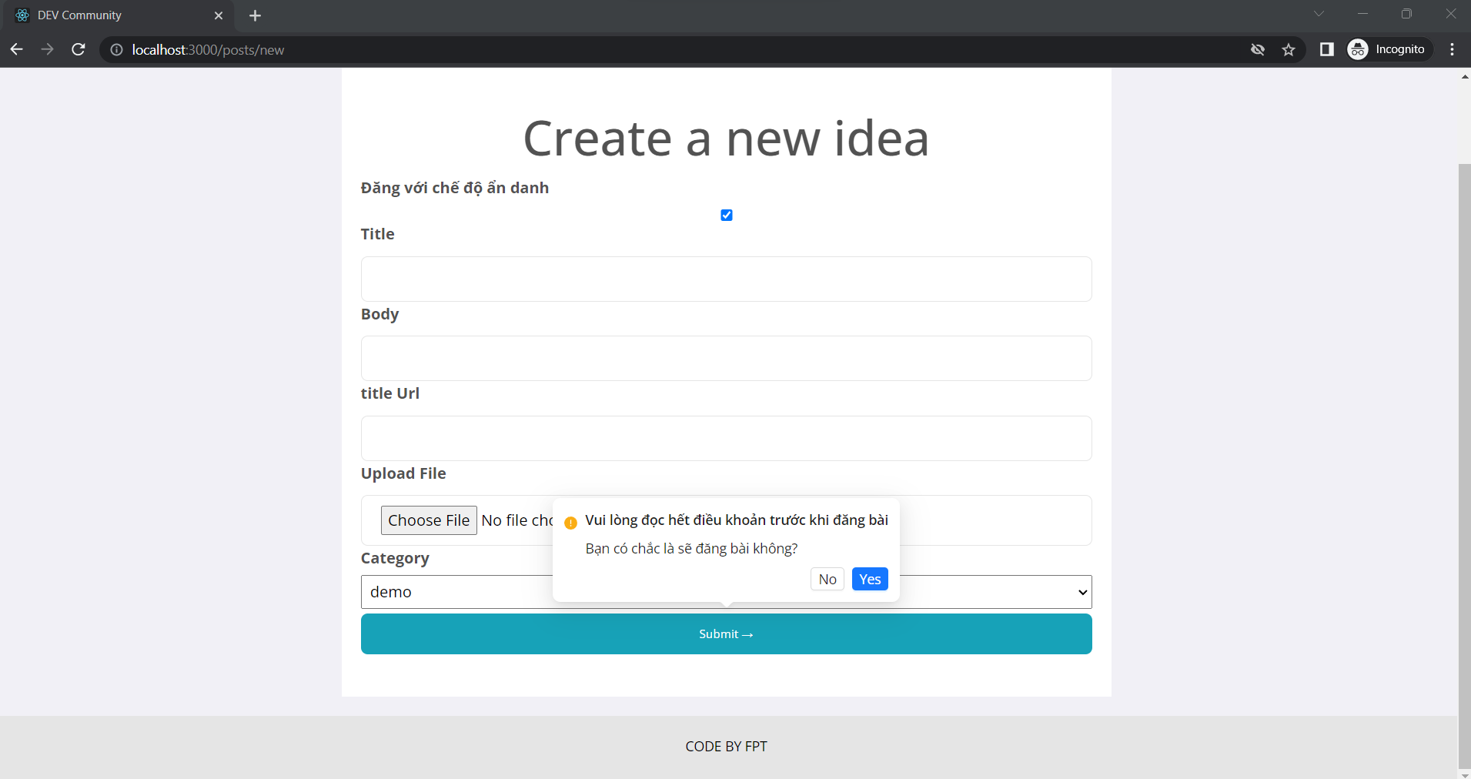

Figure 42: Agree to terms before posting ideas Page

When other users comment and like, follow you will display a notification for you.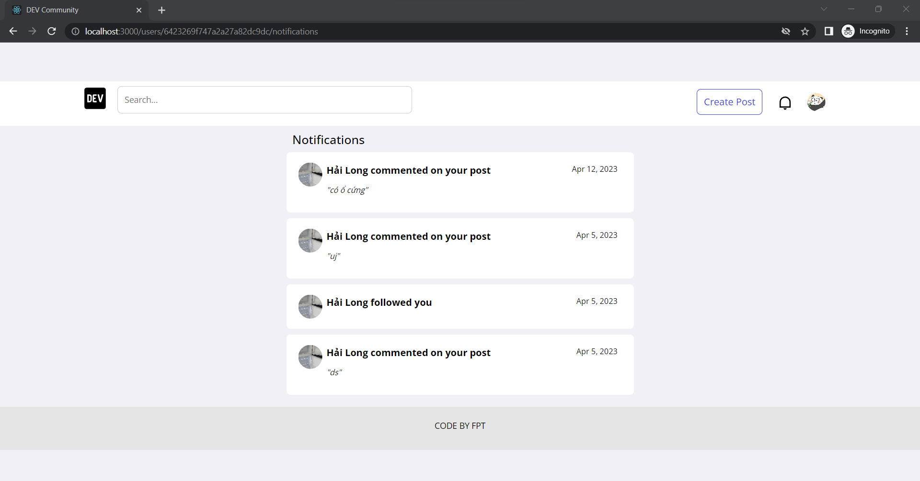

Figure 43: Notification Page

Edit profile Page

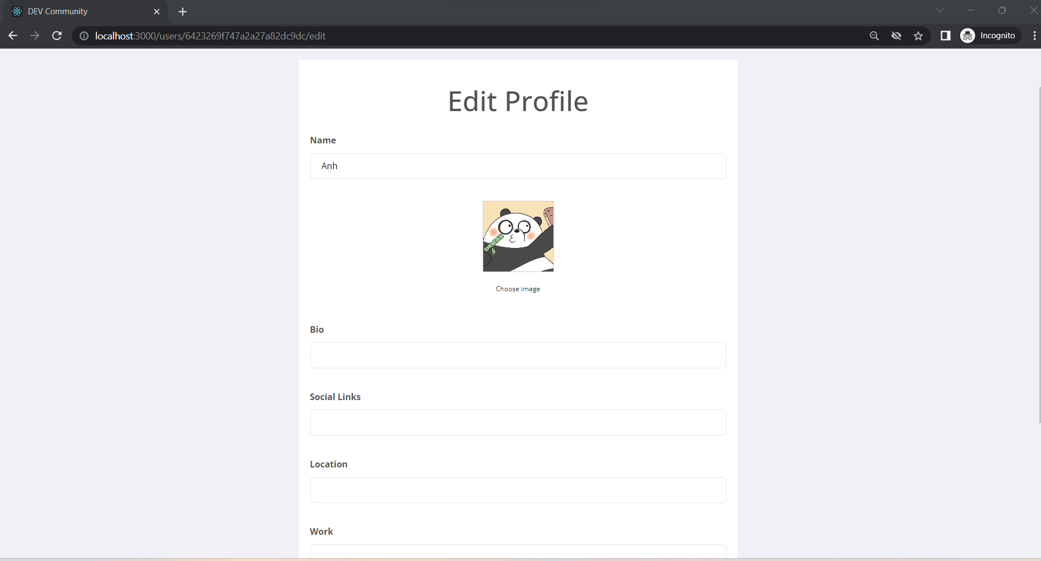

Figure 44: Edit profile Page

This is your profile page and ideas posted.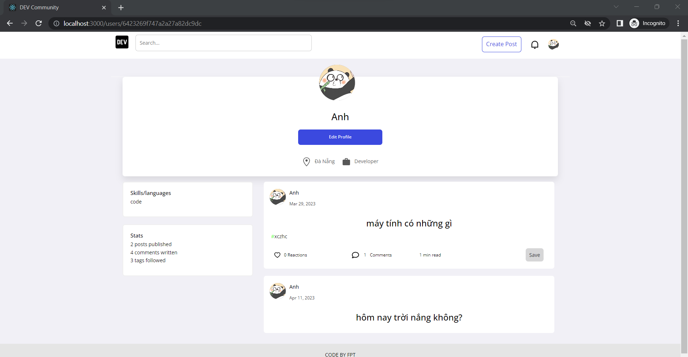

Figure 45: Profile Page

This is the idea post page when you click on view. You can like and comment here.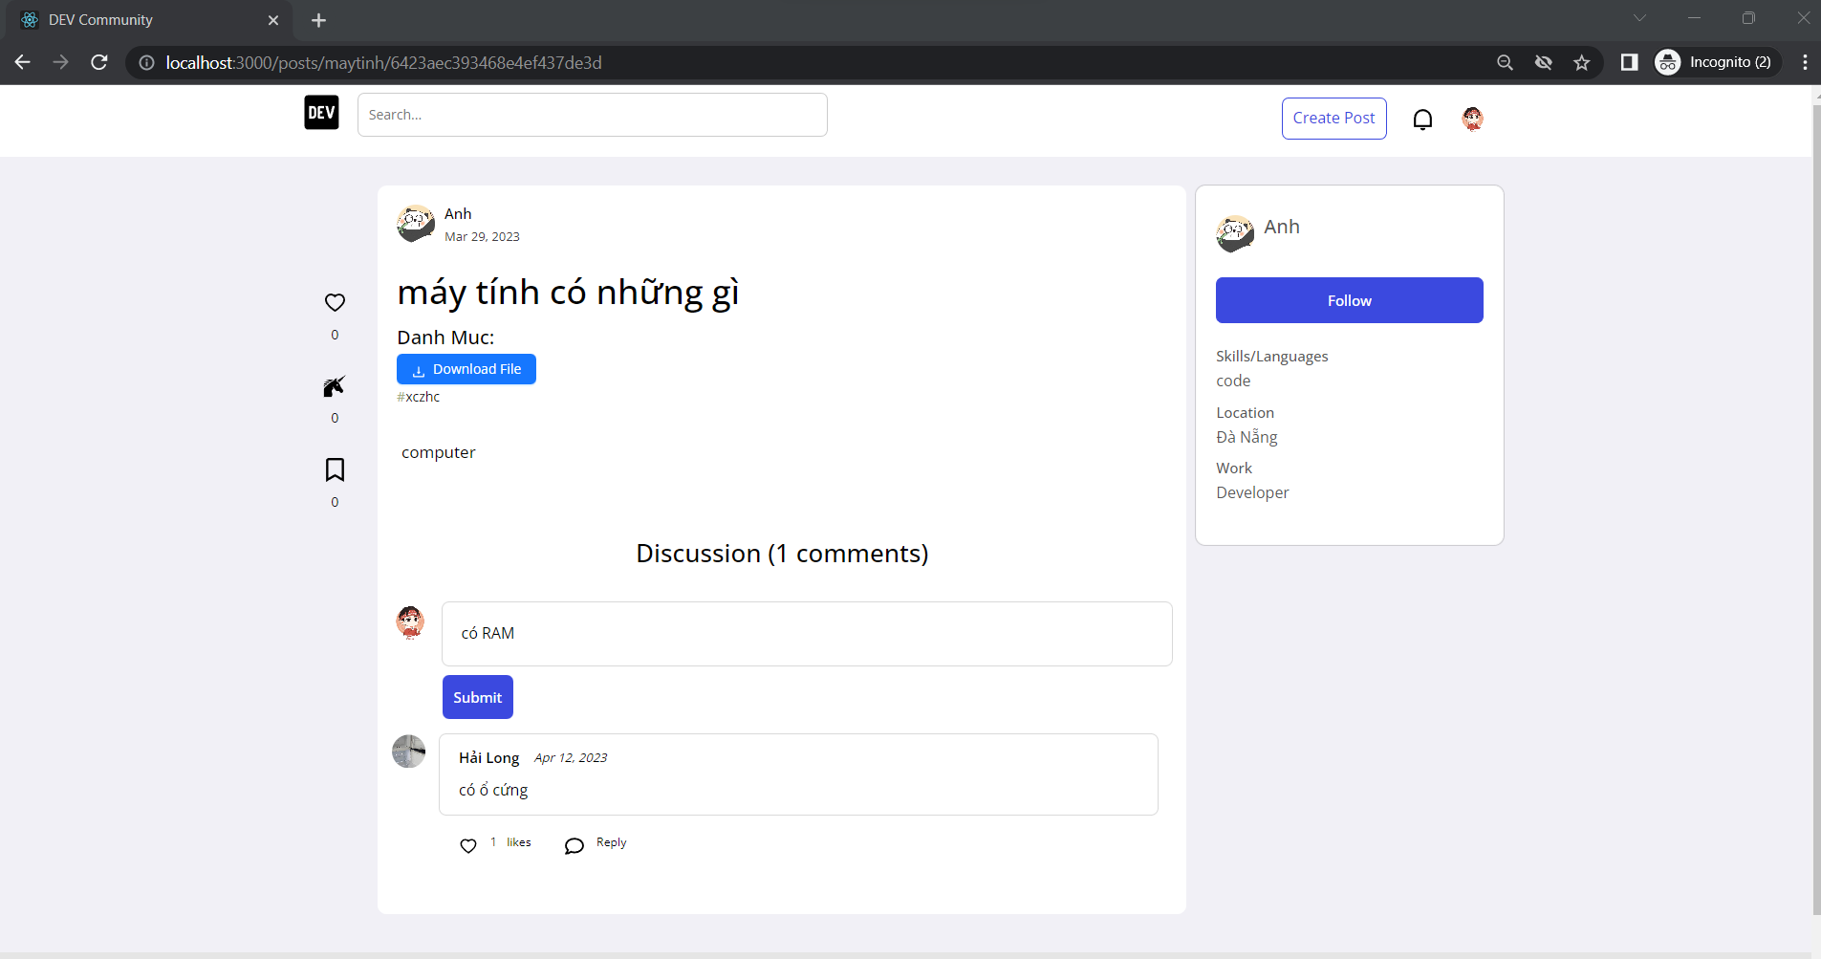

Figure 46: View Idea Page

Home page admin

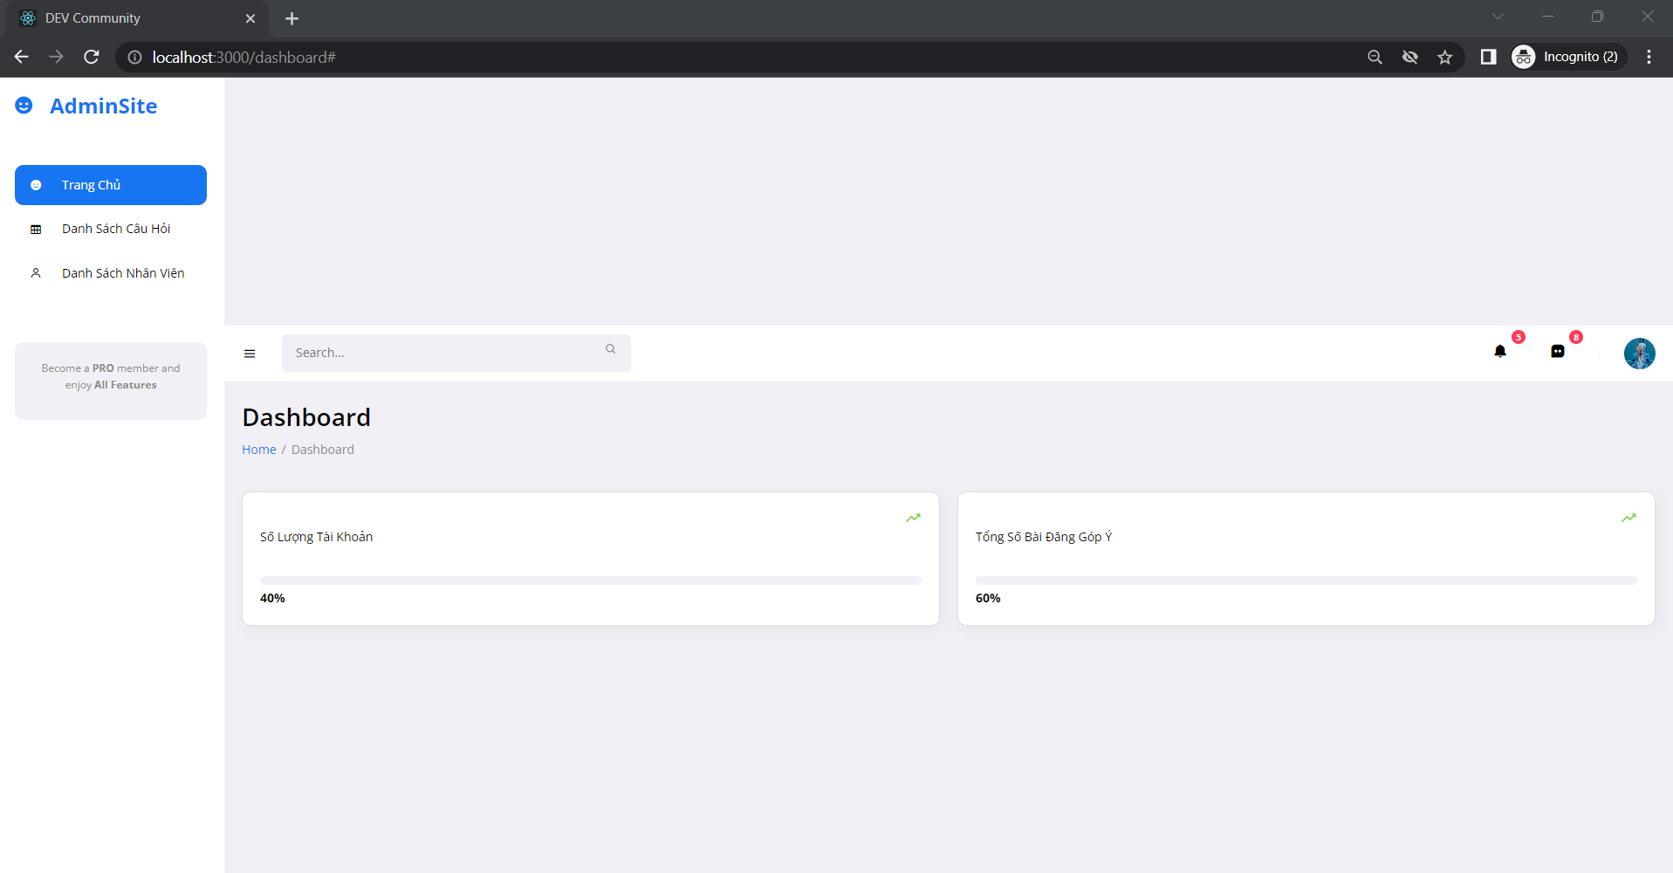

Figure 47: Home page admin

List of ideas Page

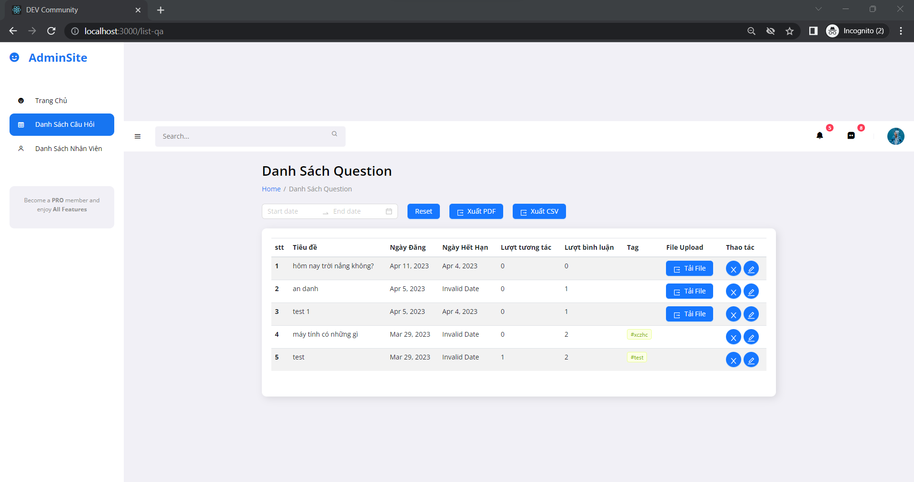

Figure 48: List of ideas Page

When you click "Xuất PDF" will display and you click "Print" will output the file.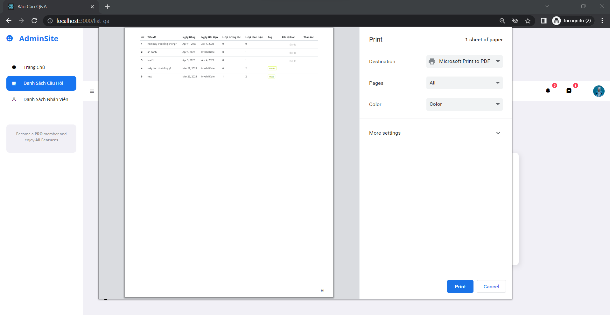

Figure 49: Export PDF Page

When you click "Edit" it will show the date for you to update the lock time of the idea that the Staff has posted.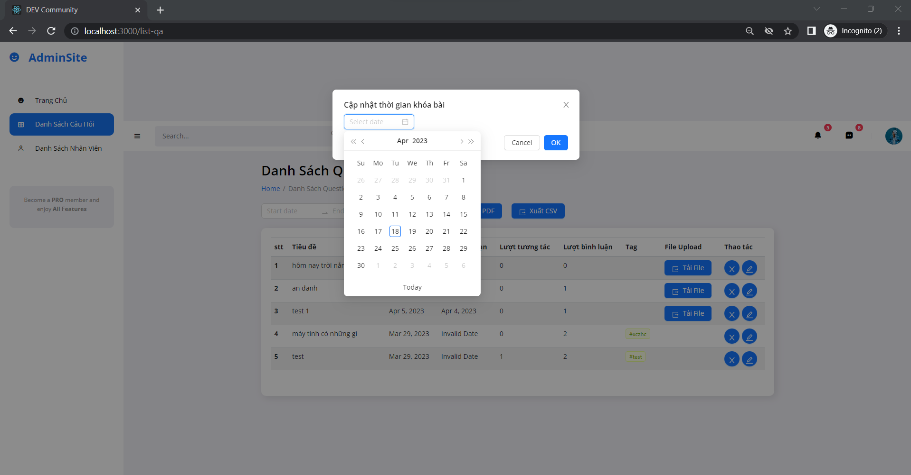

Figure 50: Update Closure Date Ideas Page

List of Staff page. Here you can export CSV files as well as PDF files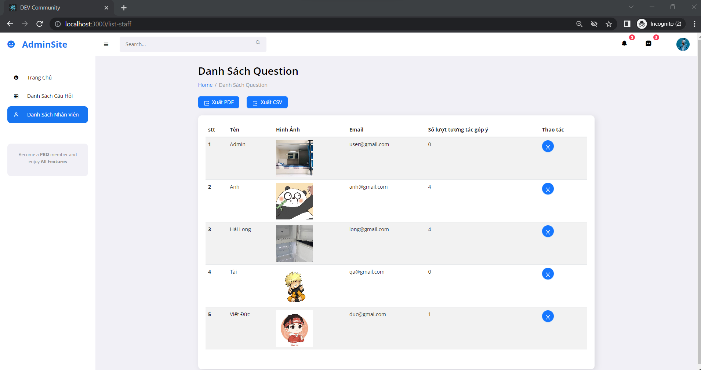

Figure 51: List of Staff Page

This is the List of category page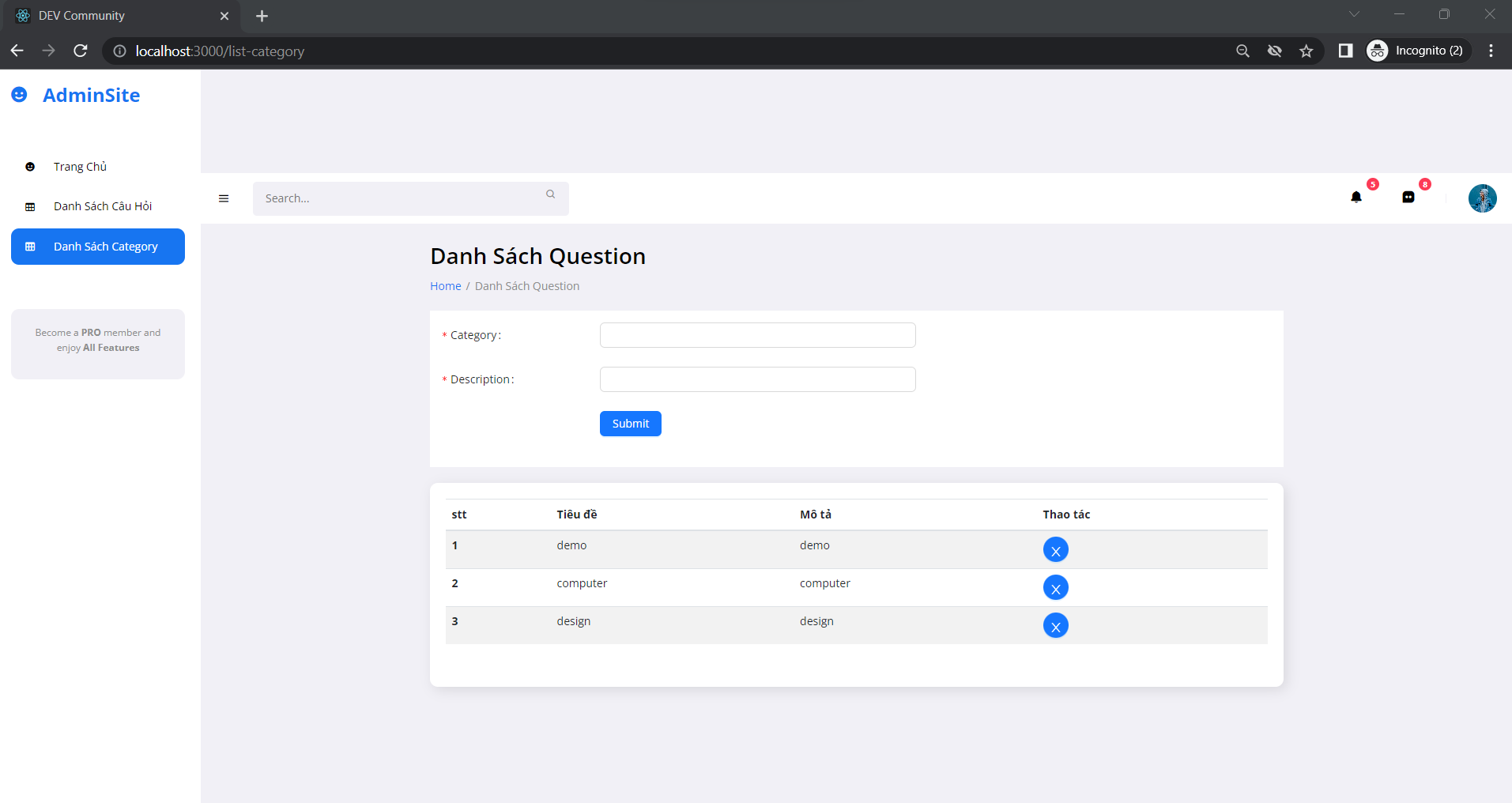

Figure 52: List of category page

Create category “manage” and notify successfully created.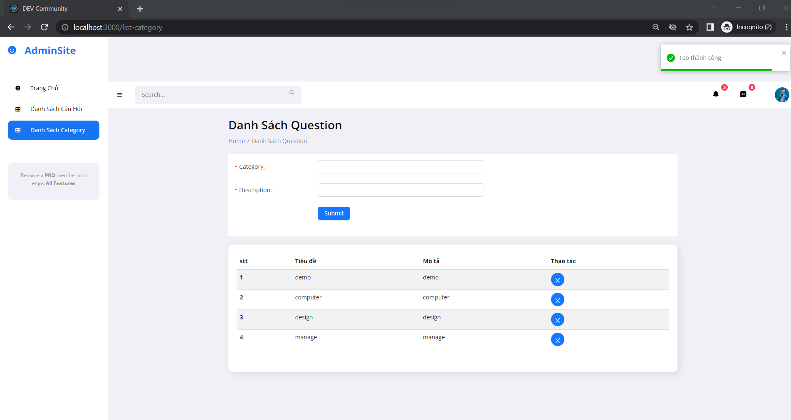

Figure 53: Create category successful

Delete category “demo” and notify successfully deleted.

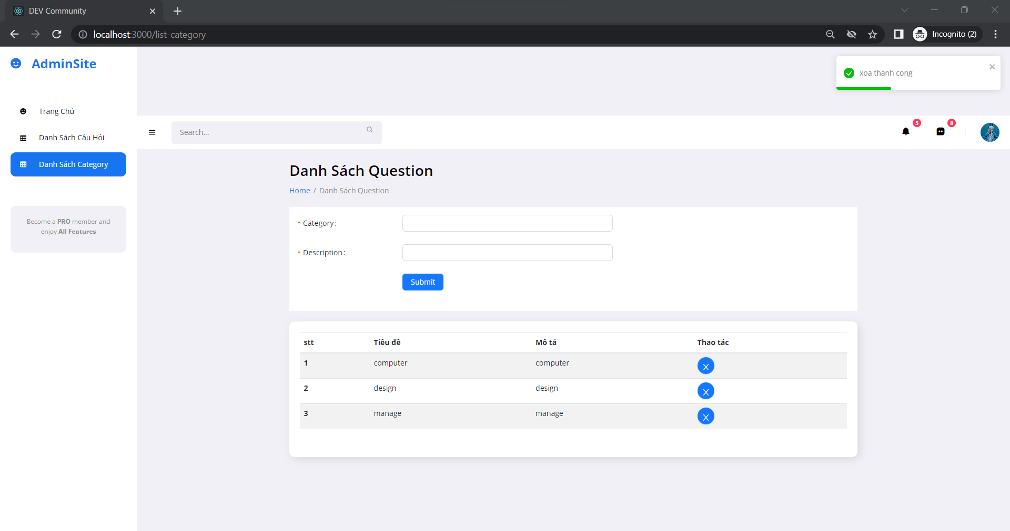

Figure 54: Delete category Successful

## Testing

Test plan, test log, sufficient data to fully test, evidence of testing finding errors

TOTAL:

PASSED: 13

FAILED: 2

Table 1: Testing

|  |  |  |  |  |  |
| --- | --- | --- | --- | --- | --- |
| **No** | **Test case** | **Input data** | **Expected output** | **Actual output** | **Evaluation** |
| 1 | Check login before creating commet | User clicks on add idea button | When the user clicks the add comment if the user is not logged in, the user will be redirected to the login page. After logging in, the user will be returned to the idea generation page. |  | Pass |
| 2 | Confirm agree to Terms and Conditions | Do not select this item | If the user does not select this item but presses submit, a message will be displayed and the user will be asked to accept the given condition.3 |  | Pass |
| 3 | Anonymous mode | User chooses anonymous mode. | When posting an article, if the user chooses anonymous mode, when the article is approved, the name will be displayed as anonymous and the avatar is anonymous. |  | Pass |
| 4 | Check login before like post | Multiply the like button | When the user clicks the delete button but is not logged in, the system will automatically redirect the user to the login page |  | Pass |
| 5 | View comments | Multiply the view comment button | When clicking on the comment view button, the entire post's comments will be displayed |  | Pass |
| 6 | Create Category | The user enters the correct information that the system requires, including: Category Name, Description | The system checks the input information to see if it matches the system's format and allows the user to create a category. |  | Pass |
| 7 | Delete Category | The user clicks on the Delete button to delete the category. | The category has been deleted from the system and the system gives a message that the category has been deleted successfully. |  | Pass |
| 8 | Edit the post's closing date | Click on the edit icon to change the idea's closing date | Admin can change the date when the post can be closed to stop all Like, comment functions |  | Pass |
| 9 | Download file PDf | Click on the icon FILE UPLOAD to download the idea. | Admin and QA can download the idea when they click on the Icon FILE UPLOAD. |  | Pass |
| 10 | Export list of Staff by CSV and PDF | Click on the icon “ Xuất PDF” Or “ Xuất CSV” to export list of Staff | Admin can export the list of Staff from site of Admin page |  | Pass |
| 11 | Export list of Idea by CSV and PDF | Click on the icon “ Xuất PDF” Or “ Xuất CSV” to export list of Idea | QA can export the list of Idea from site of QA page |  | Pass |
| 12 | Notification comment | The person who posted the Idea received a notification | Idea posters get a notification when someone comments on their expired post |  | Pass |
| 13 | Edit personal information | The user clicks on the edit button and fills in the information to be edited | After click on edit profile, it will return to the edit profile page and display the user's information |  | Pass |
| 14 | Create  Idea | The title field blank | When the user leaves the title field blank, a message will be displayed asking the user to fill in all information |  | Fail |
| 15 | Create Account | The Information field blank | When you register a new account, you fill in the missing information, the system will notify you "Invalid inputs passed, Please check your data" |  | Fail |